Become a Sponsor at the 2020 MCSS Virtual Conference
“The Stories We Tell – Accounts, Anecdotes, Authenticity”
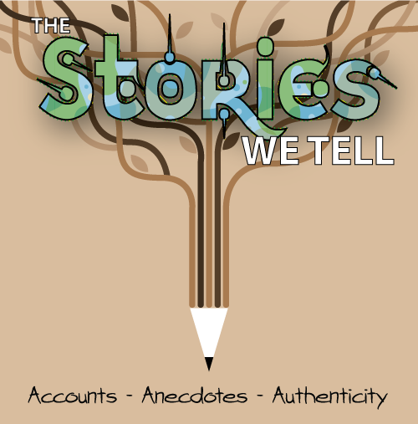
Due to the ongoing COVID-19 Pandemic, the 2020 Michigan Council for the Social Studies conference will take place <<DATEDESCRIPTION>> online. Educators from all over the state of Michigan will now be able to learn from the comfort of their homes. As an organization committed to serving these dedicated professionals, we hope you’ll join us to tell YOUR story – as well as your research, products, and solutions!
Limited sponsorship opportunities are available for 2020, so please contact us soon to discuss how your organization can support social studies education in Michigan.

Choose your Tier:

Sponsorship Benefits | Tier 1 | Tier 2 | Tier 3  (limit 2) | Tier 4  (limit 2)
Exhibitor Space – Website, Exhibitor hours, etc. – (Exhibitor space will go up 3 days in advance of the conference and remain up for 14 days after) | ★ | ★
Exhibitor Space – Website, Exhibitor hours, etc. – (Exhibitor space will go up 10 days in advance of the conference and remain up for 30 days after) |  |  | ★ | ★
Attendee Mailing List |  | ★ | ★ | ★
Company Logo, contact information on MCSS Website |  | ★ | ★ | ★
Splash Page Logo within Crowd Compass MCSS App |  |  | ★ | ★
Banner Ads within Crowd Compass MCSS App | ★ | ★ | ★ | ★
Sponsor And Exhibitor Profiles within MCSS App | ★ | ★ | ★ | ★
Presentation to Full Audience Prior to Keynote– 5 minutes |  |  | ★
Presentation to Full Audience Prior to Keynote 10 minutes |  |  |  | ★
Guaranteed Session Slot |  |  | ★ | ★
Sponsorship Costs | $250 | $375 | $500 | $1000

Reserve Your Space Today! Contact Dave Johnson at djohnson@mcssmi.org

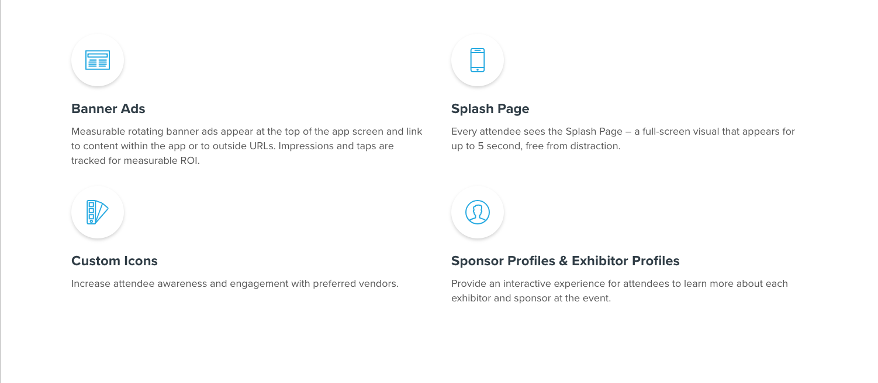
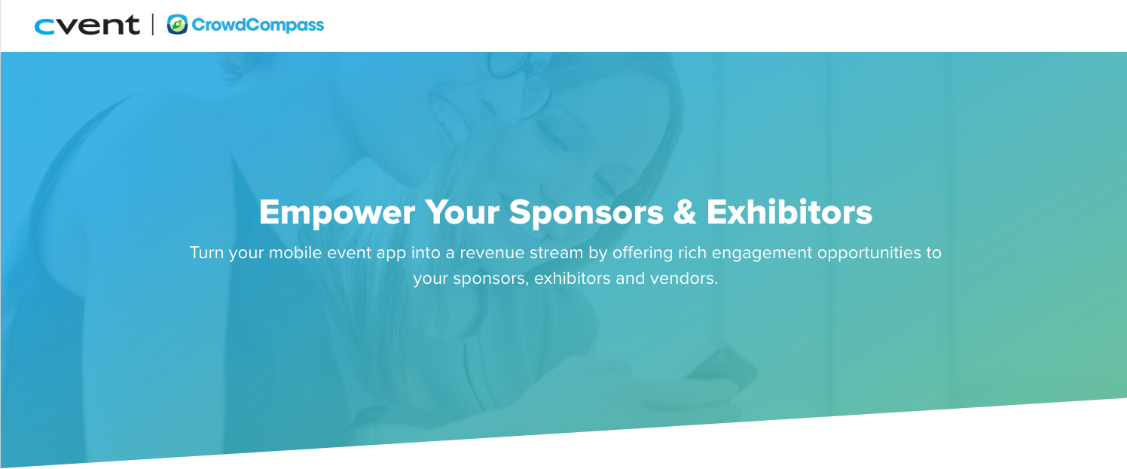
Introducing the Conference App – CrowdCompass!
Learn more about the features we’ll be providing attendees with CrowdCompass by visiting their website: http://www.crowdcompass.com

